**Equipment Required for RLCP Citizen Science Continuous Stream Discharge Monitoring**

All sampling equipment and installation materials required for continuous monitoring of stream discharge at one location are detailed in Table 1 below. A handheld Geopacks flow meter (Table 1) is required for periodic measurement of stream cross-sectional velocity, used to create a stage-discharge curve that allows calculation of discharge from continuous stage measurements. The flow meter can easily be transported between multiple flow monitoring sites as it is not permanently installed. The advanced Geopacks model automatically calculates and stores stream velocity measurements which can easily be exported to Excel, eliminating the need for volunteers to manually calculate and transcribe data.

The HOBO water level logger (Table 1) is installed in the stream for continuous stage monitoring, so one is required per long-term monitoring location. The HOBO level logger has a factory-replaceable battery that lasts approximately five years. An ambient air pressure logger is required to compensate for the atmospheric pressure exerted on the stream water column, which is included in the measurements taken by the HOBO level logger (HOBO) at the bottom of the stream. The Kestrel model (Table 1) is not designed for submersion, so is more cost-effective than using two HOBO level loggers for this purpose because the air pressure logger can be hung in a nearby tree. One strategically placed air pressure sensor would likely suffice if multiple level loggers were installed at different locations in the catchment. Air pressure data can be transferred to a phone or tablet via Bluetooth using an app. The Kestrel pressure logger uses user-replaceable batteries, which are not accounted in Table 1 because this maintenance cost is expected to be nominal and infrequently incurred.

To retrieve data from the HOBO level logger, either a HOBO base station or shuttle data transporter (Table 1) is required. The level logger must be removed from the stream temporarily to attach these for data transmission. The base station must be plugged into a laptop via USB to transmit data, it just “translates” the level logger data for the computer. The shuttle data transporter does not require a laptop be brought to the monitoring location because it has built-in memory to store level logger data permanently until it is manually wiped. This could be advantageous for allowing different volunteers to retrieve logger data, since there’s no requirement that they have a laptop with HOBO software installed. The base station and shuttle data transporter can be used with multiple level loggers across different sites and with other HOBO data logger models, such as conductivity or dissolved oxygen.

Table Materials required for continuous flow monitoring using a level logger

|  |  |  |  |
| --- | --- | --- | --- |
| Task | Item | Quantity | Price |
| Stage-Discharge Curve Establishment | [Geopacks Advanced Flow Meter with Temperature Gauge](https://www.geopacks.com/collections/stream-flowmeters/products/copy-of-advanced-flowmeter-with-temperature-gauge) | 1 | £249.99 |
| flexible [measuring tape](https://www.amazon.co.uk/Amtech-P1800-Surveyor-Tape-30/dp/B004CDQXTI/ref=sr_1_6_mod_primary_new?crid=2IH5JQV447X5D&keywords=surveyor%2Btape&qid=1668364581&sbo=RZvfv%2F%2FHxDF%2BO5021pAnSA%3D%3D&sprefix=surveyor%2Btape%2Caps%2C113&sr=8-6&th=1) | 1 | £6.91 |
| ground stakes | 2 | NA (borrow) |
| Continuous Stage Monitoring | [HOBO U20L-04 Water level data logger](https://www.tempcon.co.uk/hobo-u20l-04-water-level-data-logger-0-4m) | 1 | £502.48 (£418.73 w/o VAT) |
| [Kestrel DROP D3 Wireless Temperature, Humidity & Pressure Data Logger](https://www.tempcon.co.uk/kestrel-drop-d3) | 1 | £176.71 (£147.26 w/o VAT) |
| Level Logger Data Retrieval | [HOBO BASE-U-4 USB Universal Base Station](https://www.tempcon.co.uk/hobo-base-u-4-usb-universal-base-station) OR  [HOBO U-DTW-1 Waterproof Shuttle Data Transporter](https://www.tempcon.co.uk/hobo-u-dtw-1-waterproof-data-shuttle-u-dtw-1) | 1 | £217.36 (£181.13 w/o VAT) OR  £434.70 (£362.25 w/o VAT) |
| Logger Installation | cordless hammer drill | 1 | NA (borrow) |
| ¼ in/6mm drill bit | 1 | NA (borrow) |
| 8mm x 400mm [masonry drill bit](https://www.amazon.co.uk/Draper-DRA40671-Expert-Masonry-Drill/dp/B01089NUAO?th=1) | 1 | £5.18 |
| table saw | 1 | NA (borrow) |
| crescent wrench | 1 | NA (borrow) |
| ratcheting socket wrench | 1 | NA (borrow) |
| 6mm nut driver | 1 | NA (borrow) |
| 32mm x 200mm [PVC pipe](https://www.screwfix.com/p/floplast-push-fit-pipe-white-32mm-x-3m/26334) | 1 | £3.25 |
| Adjustable stainless steel [hose clamp](https://www.amazon.co.uk/RosewineC-Adjustable-Stainless-Securing-Connections/dp/B09Y55SG2V/ref=sr_1_17_sspa?keywords=stainless+steel+hose+clips&qid=1668355114&sr=8-17-spons&sp_csd=d2lkZ2V0TmFtZT1zcF9tdGY&psc=1) (sold in pack of 20) | 1 | £4.99 |
| 6mm x 80mm [concrete expansion anchor](https://www.amazon.co.uk/Expansion-M6x80mm-Stainless-Fixings-Concrete/dp/B092MMMNKD/ref=sr_1_13_sspa?crid=NKVM2HDW27EE&keywords=m6+stainless+steel+concrete+expansion+bolt&qid=1668360681&s=diy&sprefix=m6+stainless+steel+concrete+expansion+bolt%2Cdiy%2C76&sr=1-13-spons&sp_csd=d2lkZ2V0TmFtZT1zcF9tdGY&psc=1) (sold in 8 pack) | 2 | £8.99 |
| 6mm x 80mm [eye bolt](https://www.amazon.co.uk/80MM-Stainless-Steel-Shank-Eyebolt/dp/B014SP21YA) | 1 | £3.60 |
| 6mm [nylon locking nut](https://www.amazon.co.uk/Stainless-Steel-Locking-Metric-Thread/dp/B07H9378T6/ref=sr_1_3?crid=2C4SG3H3C0IPU&keywords=nylon+stainless+steel+locking+m6+nut&qid=1668354317&s=diy&sprefix=nylon+stainless+steel+locking+m6+nut%2Cdiy%2C87&sr=1-3) (sold in 50 pack) | 1 | £3.59 |
| 5mm [locking quick link](https://www.amazon.co.uk/sourcingmap-Stainless-Steel-Screwlock-Carabiner/dp/B01ES7JPUQ/ref=sr_1_10?crid=2I2VDAF4P2F2N&keywords=m5+carabiner+quick+link&qid=1668354941&s=diy&sprefix=m5+carabiner+quick+link%2Cdiy%2C96&sr=1-10) (sold in 2 pack) | 1 | £5.49 |
| 8mm stainless steel 2-hole [eye plate](https://www.amazon.co.uk/Stainless-Steel-Eye-Plate-8pcs/dp/B07S8P4V6T/ref=sr_1_41?crid=1GMMYCR5Z5UHP&keywords=2+bolt+eye+plate&qid=1668359286&sprefix=2+bolt+eye+plat%2Caps%2C91&sr=8-41) (sold in 8 pack) | 1 | £15.99 |
| 10m heavy-duty [stainless steel cable](amazon.co.uk/Ymwave-Heavy-duty-Stainless-Aluminum-Crimping/dp/B094QMDT4C/ref=sr_1_13?crid=1KHAKXDFUWRC6&keywords=stainless+steel+cable&qid=1668356163&sprefix=stainless+steel+cable%2Caps%2C119&sr=8-13) | 1 | £9.69 |
| Total Cost, HOBO Base Station Option | | | £1204.53 incl VAT |
| Total Cost, HOBO Data Shuttle Option | | | £1421.87 incl VAT |

Logger installation materials (Table 1) are based on anchoring the equipment to a submerged concrete slab at the farthest downstream bridge on Ickworth Estate, modified from the methods detailed by [Fogg et al. (2020)](https://doi.org/10.1111/2041-210X.13367). The same methods could be used on other streams in the Lark catchment if a suitable anchoring surface (concrete, brick, bedrock, etc.) is available. A diagram showing the assembled protection and anchoring materials for the level logger is included below (Figure 1, from Fogg et al. 2020). For installation in concrete/masonry at locations in the Lark catchment, the cement bolt should be replaced with an expanding concrete bolt (Fogg et al. 2020). For additional security, a 2-hole eye plate (Table 1) can be used rather than a rock climbing hanger plate (Figure 1), since there is no restriction on installing a second bolt, and a stainless steel cable (Table 1) can be attached to a tree or other suitable anchor on the streambank to ensure the logger is not lost in the event both bolts fail.

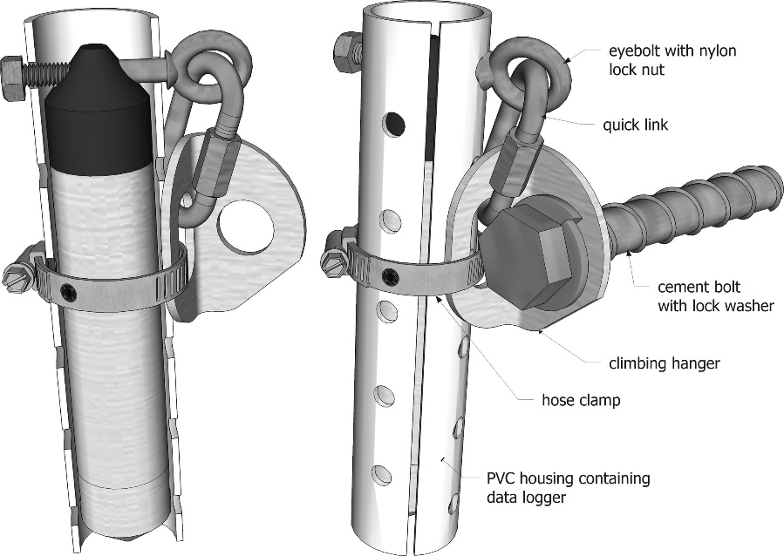

Figure Diagram of the protective housing for a HOBO water level logger installed on a rock-like surface within a streambed, from Fogg et al. 2020.

**References**

Fogg SK, O'Daniel SJ, Poole GC, Reinhold AM, Hyman AA. 2020. A simple, reliable method for long-term, in-stream data logger installation using rock-climbing hardware. Methods in Ecology and Evolution. 11(5):6. https://doi.org/10.1111/2041-210X.13367